2.AIRLINE RESERVATION SYSTEM UML DIAGRAMS

1. 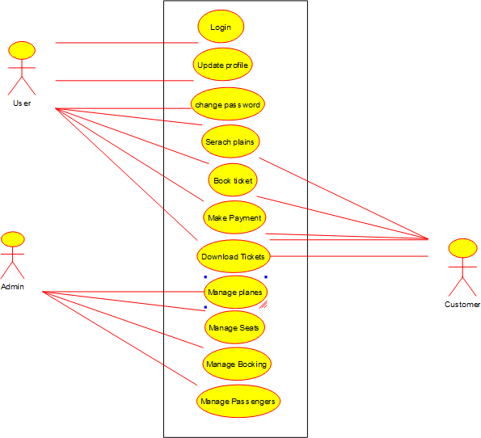**USE CASE DIAGRAM**
2. **SEQUENCE DIAGRAM**

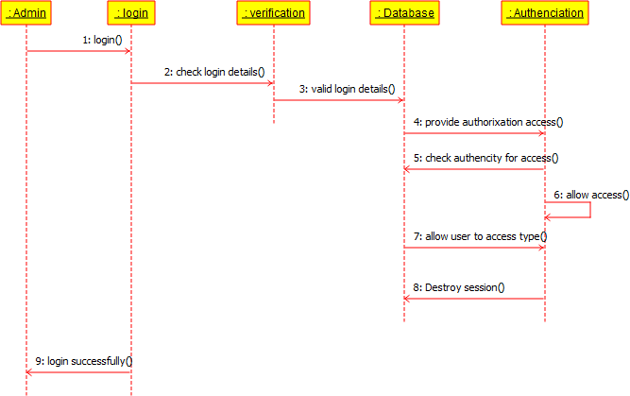

1. **CLASS DIAGRAM**

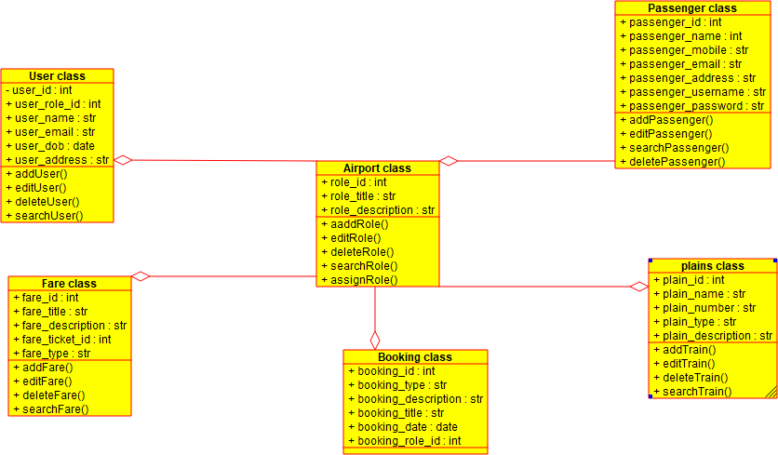

1. **STATE DIAGRAM**

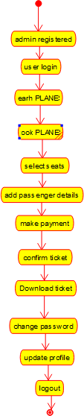

1. **ACTIVITY DIAGRAM**

